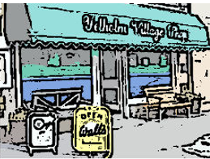

EXPRESSIONS OF INTEREST – UPDATE JUNE 2020

We are very pleased to provide an update on the results of our initial Expressions of Interest campaign. To date, we have received indications of support in excess of £108,000 from 234 individuals, which reflects a combination of donations and pledges to buy shares* in the Community Benefit Society (BenCom).

We want to sincerely thank the community for this very encouraging start. No offer of support is too small. We still have a most challenging road ahead as we continue to seek grants. The competition for funding as a result of the COVID emergency has made the process much more difficult. As a reminder, we need to obtain a positive response from the Scottish Land Fund before we can proceed with the BenCom share offer, as well as obtaining further funding to complete the full scope of repair and renovation that we have proposed.

We will provide further updates as soon as we can, but in the meantime we welcome receiving any further Expressions of Interest.

*share price to be confirmed, but likely to be £25

