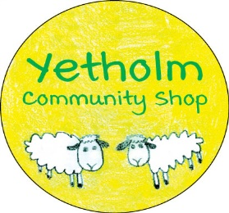

Management Committee Report on the Membership of the Society
The number of shareholders in our Society now stands at 214.
Since shares were issued following the share offer which was launched in October 2020 to the community generally we regret to report that two members have died. We also have to report that one new member has joined.
As our share offer last October raised funds well up to target levels, and with the prospect of support from the Regeneration Capital Grant Fund, we have not sought more community share capital in order further to increase the Society’s financial resources.
However, if new individuals or organisations wishing to associate themselves with the Society’s vision and objectives apply for membership, our practice will be to issue one single share to them against payment of £25, the same par value as that of the shares offered last October. On that basis we would welcome new supporters.
This does not preclude a further share offer to the community generally at some future point, but at present the Management Committee has no plans for that.

The Management Committee
15 November 2021

