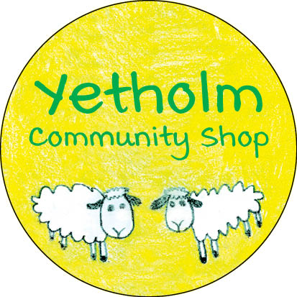
UPDATE – JANUARY 30, 2021
We have been very busy since our last update; here’s a summary of some of the key activity as we continue to work to bring the shop into community ownership:
Purchase of the premises and the business – we reported in our last bulletin that the conveyancing process was moving a little more slowly than we had hoped. A further update will be provided as soon as we can.
Preparations for day one of community ownership – we want to make the transition as smooth as possible, so we have been introduced to the main wholesale suppliers to the shop and are working to arrange contracts for telephone/broadband, electricity, water, etc. While new freezers and chillers will be required as part of the refurbishment, we are looking to acquire an immediate replacement for the broken fridge which is out of service. We also plan to introduce a computerised Point of Sale system which will help us to manage our stock and cash flow more efficiently. An initial demonstration has been made to the shop staff and the management committee.
Retail consultant – we engaged a very experienced retail consultant for a day-long meeting before Christmas. We are reviewing his initial report to see where he might be able to assist us in a number of areas as we refresh the look of the shop.
Temporary location – the plans for repair and refurbishment will mean that we cannot occupy the shop while this is being done. We want to be able to continue to trade and serve the community during this period, so we are pleased to advise that the trustees of the Youth Hall have agreed in principle for us to temporarily relocate the business there for the duration of the work. It is unlikely that we will be able to relocate the Post Office counter, so we are investigating if a mobile service can be arranged. More information on this will follow.
Other funding – we were pleased to receive a small grant from ‘Scotland Loves Local’ which is a new fund established by the Scottish Government. This will be used to purchase a new laptop computer and printer and to cover the costs of training volunteers. We have also been advised that we have been recommended for funding from the Scottish Government’s Regeneration Capital Grant Fund, and more information about this will be provided in due course.
We are close to realising the vision of a community owned shop!
Thanks to everyone who has provided support and encouragement.
More news to follow soon!

