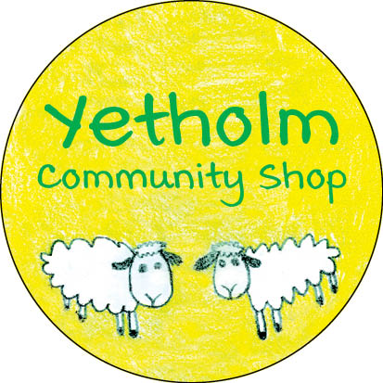
UPDATE – MARCH 14, 2021

SHOP BUYOUT DATE SETTLED!

We are very pleased and excited to announce that the purchase agreement has at last been finalised, and we can now confirm the proposed date for the ownership of the shop to transfer to the community benefit society. As things now stand, Yetholm will have a community-owned village shop on March 22, 2021!
While we can all take a moment to celebrate this important milestone in our project, we should emphasise that this is also just the start of the next stage of our journey. There is still a tremendous amount of work to be done in order to take the shop forward as a successful community business. We will now be proceeding with the plans for repair and refurbishment, and will provide further updates on this in our next bulletin. While in the early days the shop will not look much different, remember that by supporting the shop, you will be supporting our community.
As we need to apply to the Post Office to formally transfer Barbara Maltby’s role as postmistress, and this will take some time, we are very pleased that Barbara has agreed to continue in an interim role until this has been finalised.
We also some have further news to report. After many years of service as shop manager, Janice Gillies has announced her intention to step away from this role and leave the shop. While we all will be very sad to see her go, we are delighted that she has agreed to stay on for a transition period. Janice has been incredibly helpful to us throughout the buyout process, and we are sure that you will all join the management committee in thanking her for her contributions and wishing her well for the future.
We also wish to thank Karon Phillips for her work on the management committee. Karon joined the committee to bring her fundraising skills to the project. Now that our initial major fundraising goals have been achieved, Karon has decided to step down from the committee.
Finally, we must give a particular acknowledgement to Roy and Barbara Maltby. Not only have they been most collaborative in working with the committee to allow us to reach this point, without them it is very likely that we would have lost our shop some time ago – thank you Roy and Barbara!

WELL DONE YETHOLM – WE HAVE SAVED OUR SHOP!

