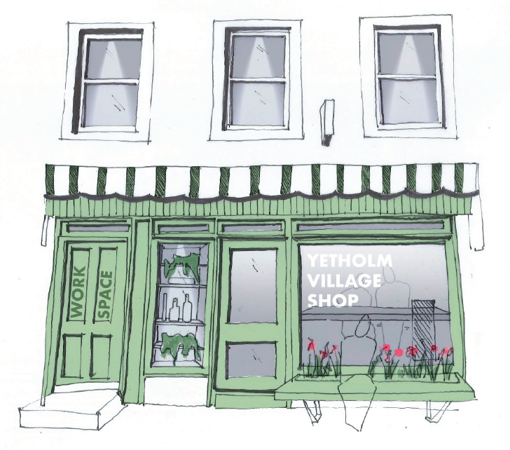

YETHOLM VILLAGE SHOP - UPDATE BULLETIN
While we had previously indicated that a decision regarding our Scottish
Land Fund Stage 2 grant application was expected before the end of August,
SLF has now confirmed to us that the announcement of the outcome of this
funding round will be made on September 17. This is not an unusual development, and in the meantime we will continue to work to take the project forward and will broadcast the SLF response to the community as soon as it is received.

Dated: August 28, 2020

