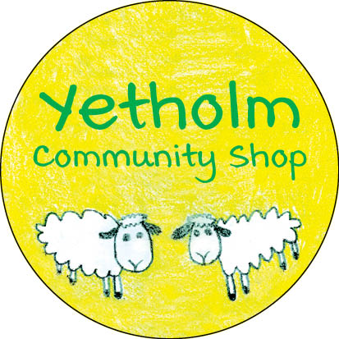

FUNDRAISING UPDATE – NOVEMBER 23, 2020

GREAT NEWS!

We are still processing the most recent subscription/donation forms, but we are delighted to announce that our fundraising campaign has achieved a total in excess of £145,000, (subject to tidying up loose ends and doing a bank reconciliation). This means that we have sufficient funds for the project to go forward! In the meantime, it’s still not too late to apply for shares or to donate.
We will of course provide another update with the final total and a breakdown between the share subscription and donation amounts, but we wanted to share this exciting news with everyone at the earliest opportunity.
Our immediate task now is to push forward with negotiations with Roy and Barbara on the formal contract for the purchase of the shop premises and its business.
This result has unquestionably shown the strength of our community spirit and how much we value our shop as a core element of Yetholm. Well done everybody - stay tuned for more updates!

