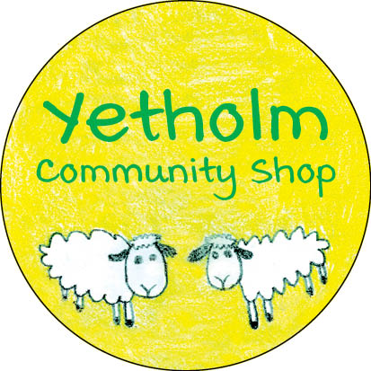

FUNDRAISING UPDATE – DECEMBER 6, 2020

We now have updated figures for the aggregate proceeds of last month's share offer and donations received to date, and are pleased to announce that we have achieved a very impressive total of £153,041 for the fundraising campaign (subject to final reconciliation).
This amounts to £119,075 in share subscriptions (from a total of 213 individuals who will become members of the community benefit society and eligible to vote at general meetings) and £33,966 in donations from 61 individual donors. We want to wholeheartedly thank again everyone who has supported the project this far.
The cheques held by us while the offer was current have now been presented to our bank for crediting. Share certificates and acknowledgements to donors are under preparation, and will be issued to each supporter in the near future.
In the meantime, our immediate next steps are to conclude the purchase of the premises and the shop business, refine our repairs and renovations plans, get ready to launch the planning application process, and work with local tradespeople to establish time frames around the work that needs to be done.
Look out for more updates soon!

