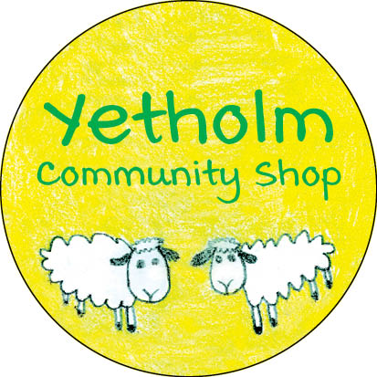

UPDATE – DECEMBER 22, 2020

As we reported in previous bulletins, we are moving forward with negotiations with Roy & Barbara on the formal contract for the purchase of the shop and the business. However, the solicitors have indicated that the conveyancing process will take a little longer to complete than anticipated. It is now our expectation that the transfer to ownership by the benefit society will occur around the end of January.
All those who purchased shares in the benefit society should by now have received their share certificates, and all donors a note of thanks. If you have not heard from us, please contact either Alastair Hirst (alastair.hirst@yahoo.com) or Kay Greenhorn (kaygreenhorn@hotmail.com). We were pleased to be able to take advantage of a grant from Community Shares Scotland to cover the costs of printing and posting the share certificates and cards of thanks, thus avoiding the need to use benefit society funds.
The management committee is continuing to work diligently on all of the many practical aspects which need to be dealt with leading up to and following the purchase, and further updates will follow.
To have reached the point in this particularly challenging year of being close to realising the vision of a community owned shop is a great achievement. As we look forward to the New Year, the management committee would like to express our thanks for your support, and wish all a very happy, peaceful and safe Christmas.

